Project 1 – Campus Marketplace
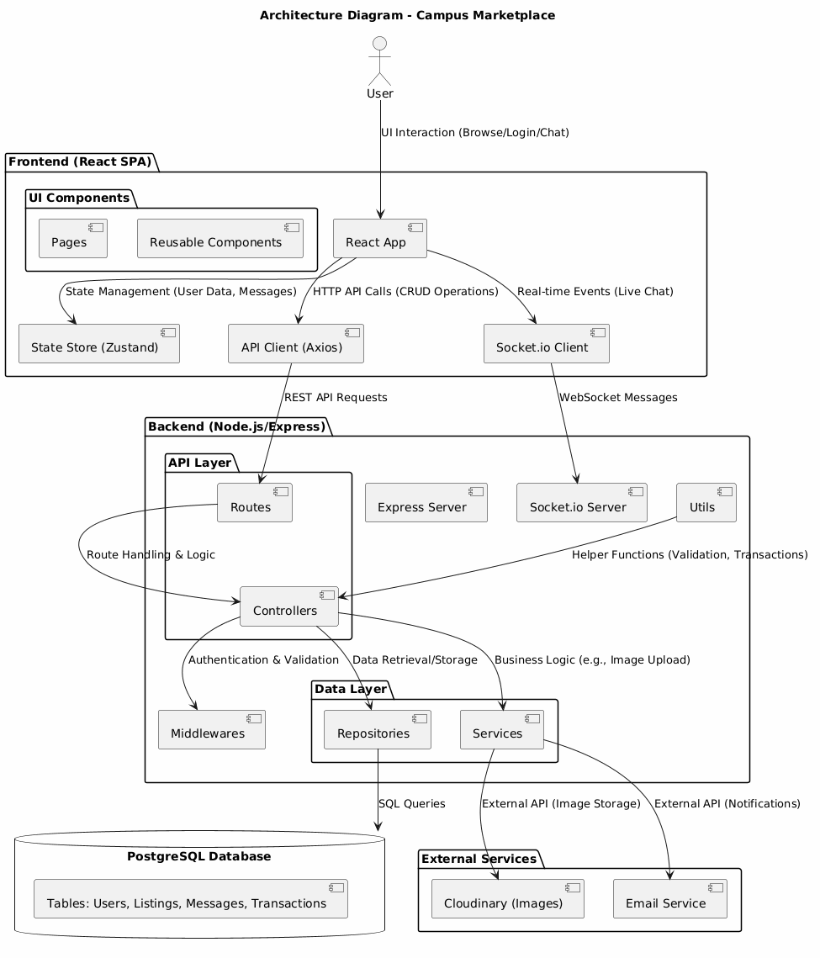
Q1. Can you explain the overall architecture of your Campus Marketplace application?
It's a full-stack web app designed for university students to buy and sell items within their campus community. It includes features like secure user authentication, item listings with image uploads, real-time messaging, and transaction handling with OTP verification for safe handovers.
Breaking it down into layers:
- Frontend: Built as a React single-page application using Vite for fast builds. It leverages Zustand for global state management, React Router for client-side routing, Axios for API communication, and Socket.io for real-time chat and notifications. Tailwind CSS provides the styling, keeping the UI responsive and modern.
- Backend: Powered by Node.js and Express.js, forming a RESTful API. Socket.io is integrated for bidirectional real-time features. The code is structured with routes for different endpoints (like auth, listings, and messages), controllers handling business logic, repositories abstracting database interactions, and middlewares for tasks like authentication and file uploads. Security is a priority, using JWT for tokens, bcrypt for password hashing, and tools like Helmet and CORS for protection.
- Database: We use PostgreSQL, hosted on Neon for serverless scalability. The schema includes tables for users, campuses, listings, messages, and transactions, with migrations managing schema changes. This relational setup supports complex queries and relationships efficiently.
Key integrations include Cloudinary for image storage and optimization, Nodemailer for email notifications, and Zod for input validation. The architecture separates concerns well, making it maintainable and scalable— for example, the repository pattern allows easy data layer changes. Real-time elements like chat enhance user engagement, and security measures protect against common threats. Overall, it's built to handle campus-specific needs while being robust for growth.
Q2. How did you implement real-time communication between buyer and seller?
In the Campus Marketplace, real-time communication is handled through Socket.io, which enables bidirectional, event-driven messaging between the frontend and backend.
On the backend, we set up a Socket.io server in server.js, integrated with the Express HTTP server. Users connect via WebSocket, and we manage rooms for private chats—when a user joins a chat (e.g., for a specific listing), they emit a join_chat event with the room ID, and the server adds them to that room using socket.join(roomId). Messages are sent via send_message, which emits receive_message to others in the room, ensuring only participants see the chat.
On the frontend, the React app uses the Socket.io client, connected via Zustand store. It listens for incoming messages and updates the UI instantly. We also added global notifications: users register for site-wide alerts via register_global, so they get toasts for new messages even outside the chat page.
This setup provides low-latency, real-time chat without polling, enhancing user experience for negotiations. It's scalable for multiple concurrent chats, and we use E2EE for message security.
Q3. How does your JWT-based authentication work? Why did you choose JWT?
JWT (JSON Web Tokens) handles authentication by providing stateless, secure user sessions.
When a user logs in, the backend (authController.js) verifies their email and password against the database. If valid, it generates a JWT using jsonwebtoken.sign(), embedding the user ID as payload, signed with a secret key from environment variables, and set to expire (e.g., 30 days). The token is sent back to the client.
The frontend stores the token in localStorage and includes it in the Authorization header for API requests. On the backend, the authMiddleware.js intercepts requests, extracts the token, verifies its signature and expiration using jwt.verify(), and attaches the decoded user ID to req.user for route handlers.
We chose JWT over session-based auth because it's stateless—no server-side storage needed, making it scalable for distributed systems like ours (deployed on Vercel and a cloud backend). It also works well with SPAs, reducing server load. However, we handle token refresh securely to avoid exposure.
Q4. Why did you use bcrypt? How does hashing improve security?
We use bcrypt for password hashing to securely store user credentials.
In authController.js, during registration, we generate a salt with bcrypt.genSalt(10) and hash the password with bcrypt.hash(). The hashed password (including salt) is stored in the database. For login, we compare the input password against the hash using bcrypt.compare(), which re-hashes and checks equality.
Hashing improves security by making passwords irreversible— even if the database is breached, attackers can't easily reverse-engineer plain passwords. The salt adds randomness, preventing rainbow table attacks, and bcrypt's adaptive cost factor (set to 10) makes brute-forcing computationally expensive. This protects against common threats like credential stuffing. We didn't use plain hashing like MD5 because it's fast and vulnerable; bcrypt's slowness is a feature for security.
Q5. What role does Zod play in your application? Why not just rely on frontend validation?
Zod provides schema-based validation for API inputs on the backend, ensuring data integrity and security.
In validators.js, we define schemas like registerSchema using Zod's fluent API (e.g., z.string().email() for email validation). In controllers (e.g., authController.js), we parse req.body with schema.parse(), which validates and transforms data—throwing errors for mismatches.
We don't rely solely on frontend validation because it can be bypassed (e.g., via API tools or malicious scripts), leaving the backend vulnerable to invalid or malicious data. Zod adds a robust layer: it sanitizes inputs, enforces types, and provides clear error messages, preventing issues like SQL injection or malformed data. Combined with frontend checks, it creates defense in depth.
Q6. How did you design your database schema for listings, users, and chats?
I used a relational PostgreSQL schema with clear entity relationships.
- users stores student accounts and links to campuses via campus_id.
- listings stores items, references seller_id and campus_id, and keeps images as a TEXT[] of Cloudinary URLs.
- messages stores chat history with listing_id, sender_id, receiver_id, encrypted_content, timestamps, and is_read.
- transactions stores the handover flow with listing_id, buyer_id, seller_id, otp, status, and completed_at.
This design keeps user, listing, chat, and transaction data normalized, supports campus-specific marketplaces, and makes history/chat queries efficient with joins.

Q7. What do you mean by optimizing a serverless PostgreSQL pool?
For Neon-style serverless Postgres, the pool must be tuned for connection reuse and transient database wake-up.
- I use pg.Pool in db.js with max: 20 and idleTimeoutMillis: 30000.
- I also set connectionTimeoutMillis: 30000 so the app waits long enough for Neon to wake safely.
- Queries use pooled clients and release them cleanly, avoiding too many open connections.
That prevents connection storms, improves stability, and avoids errors when the database scales from idle to active.
Q8. How did you integrate Cloudinary for image uploads? Why not store images in your database?
I integrated Cloudinary with a dedicated config file and upload middleware.
- cloudinary.js loads Cloudinary credentials from .env.
- uploadMiddleware.js uses multer memory storage, processes images with sharp (resize + WebP), then uploads with cloudinary.uploader.upload_stream.
- The app stores only secure_url links in the listing record.
I did not store binary images in the database because:
- databases are not optimized for large media blobs,
- it increases storage and backup cost,
- Cloudinary gives CDN delivery, resizing, and caching benefits.
Q9. How did you implement OTP verification for transactions?
I built a secure transaction flow with email-based OTP verification.
- When a buyer reserves an item, transactionController.reserveItem generates a random 6-digit OTP.
- It calls transactionRepo.createTransaction, which:
  - updates the listing to Reserved,
  - inserts a pending transaction record with the OTP,
  - uses a DB transaction (BEGIN / COMMIT) to keep it atomic.
- The OTP is emailed to the buyer and is not returned to the client.
- To complete the handover, verifyHandover finds the pending transaction, checks the OTP, then transactionRepo.verifyTransaction:
  - verifies the OTP,
  - marks the transaction Completed,
  - updates the listing to Sold,
  - all inside a database transaction.
This ensures a secure, atomic transition from reserved to sold.
Q10. What is the role of Helmet and CORS in your backend?
- Helmet secures HTTP headers by enabling protections like content security, XSS prevention, and MIME sniffing protection.
- CORS controls which origins can call the API and which headers are allowed.
In app.js, I configured CORS to allow the frontend origins and the Authorization header. Together they reduce attack surface and ensure only trusted clients can interact with the backend safely.
Q11. What challenges did you face in this project and how did you solve them?
- CORS and deployment origins: When the frontend was deployed on Vercel, the backend needed explicit origin settings and Authorization headers in app.js. I solved it by configuring CORS to allow the frontend domains and required headers.
- Serverless PostgreSQL behavior: Using Neon or similar serverless Postgres meant connections could wake slowly and drop unexpectedly. I tuned db.js with a pooled max client limit, idleTimeoutMillis, and increased connectionTimeoutMillis so the app handles cold starts more reliably.
- Image upload and optimization: Uploading raw files directly was inefficient. I built uploadMiddleware.js to use multer memory storage, compress and convert images with sharp, then upload to Cloudinary. That keeps the database lean and improves frontend load times.
- Real-time messaging consistency: Chat required both socket events and persistent history. I used Socket.io in server.js for live room-based messaging and also saved encrypted chat records in messages through messageRepository.js.
- Secure transaction handover: Ensuring a safe buyer-seller exchange needed an OTP flow. I implemented reserveItem and verifyHandover in transactionController.js with database transactions in transactionRepository.js, so listing reservation and completion are atomic.
Q12. If you scale this to 10,000 users, what changes would you make?
- Horizontal backend scaling: Keep the API stateless and deploy behind a load balancer. Use multiple instances of the Express server and ensure sockets scale with a Redis adapter for Socket.io.
- Optimize database access:
  - Add indexes to frequently queried fields like listings.status, messages.receiver_id, and transactions.status.
  - Use read replicas or partition large tables if needed.
  - Cache common reads with Redis, especially for listings and inbox metadata.
- Streamline real-time architecture:
  - Use a Socket.io adapter like socket.io-redis so chat connections work across multiple server instances.
  - Consider offloading notifications to a pub/sub system rather than single-process socket routing.
- Improve media delivery: Keep using Cloudinary or CDN-hosted images, and avoid storing blobs in Postgres. This reduces DB load and speeds image delivery.
- Add observability and rate limiting:
  - Enable rate limiting in app.js for API protection.
  - Add logging, metrics, and monitoring for request volume, DB pool usage, and socket health.

